Anil Kumar Dwivedi

Security Guard Management system

**DML Commands**

**Insert Command security_departments**

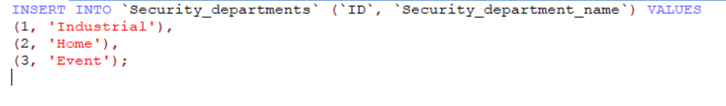

**Table**

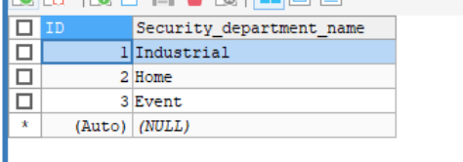

**Insert Command security_guards_details**

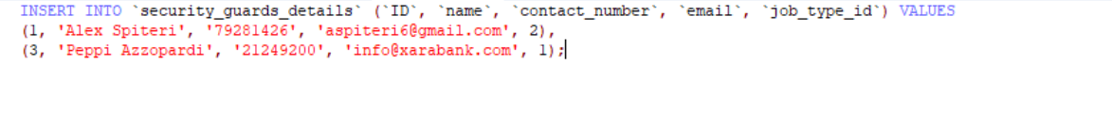

**Table**

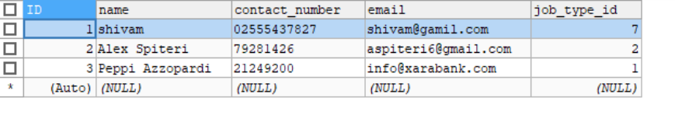

**Insert Command guard types**

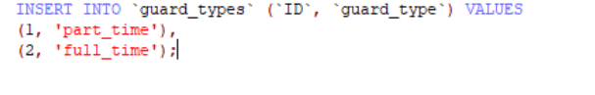

**Table**

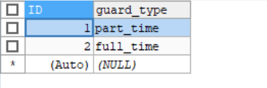

**Insert Command into salaries**

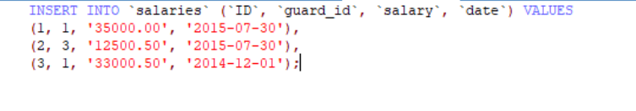

**Table**

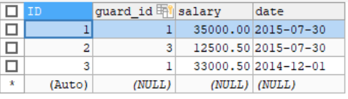

**Update Records where id=1**

**Before**



**Command**

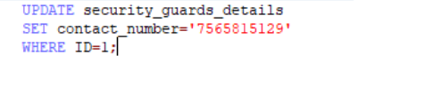

**After**

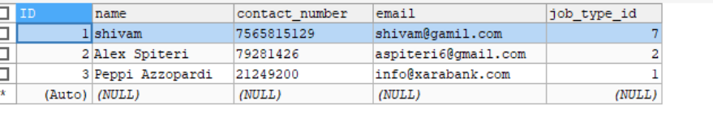

**Delete Record where id=2**

**Before Deleting**



**Command**



**After Deleting**

